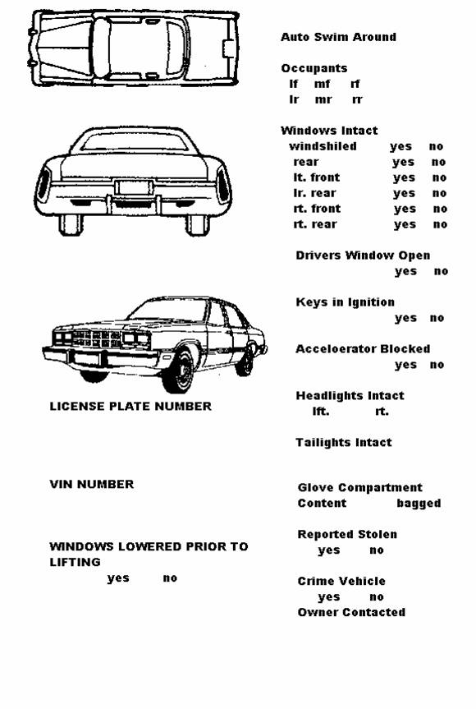**PSDiver AUTO RECOVERY**