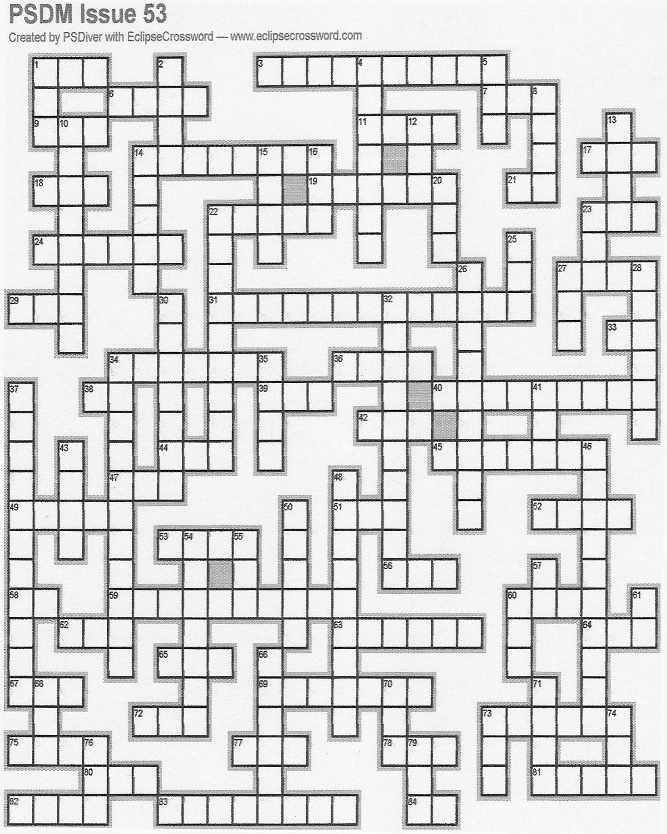
Across

1. Workout site
3. Bleeding
6. Attention getting sound
7. No less
9. Underwater craft
11. Cut off
14. In fishing, a comparatively short set line used near shore or along streams. (2wds)
17. Snooze
18. Found after a firearm has been discharged
19. The outer and slightly shorter of the two bones of the human forearm
21. Us
22. Underwater Imaging
23. Honey
24. A friction or ascending knot commonly used in belaying and climbing
27. Expired
29. An air supply
31. Death brought about by electricity
33. Pa's partner
34. To accuse formally or explicitly.
36. Red and Black
38. Not stop
39. One __ time (2wds)
40. A person sexually attracted to young children.
42. Wood thickness
44. Tell tales
45. The larvae of the fly family
47. Deli loaf
49. A loop that closes under strain.
51. Snaky creatures
52. Precipitation
53. Self-contained breathing apparatus
56. Weapons of Mass Destruction
58. Not out
59. An offense punishable by a fine or other penalty, but not by incarceration
60. Bond money paid to a court, by or on behalf of a criminal defendant, as security that, when released from jail, the defendant will appear at future hearings.
62. Unit of electrical conductance
63. A microscopic, single-cell form of marine or fresh-water algae, having siliceous cell walls.
64. Interrogate
65. Unit of 1/1000 inch used for measuring thickness of wire
67. Evil act
69. Warned
72. A small vessel that uses an inboard jet drive as its primary source of propulsion.
73. To remove the triggering device
75. Norway's Capitol
77. Curve
78. Unit of illumination equal to one lumen per square meter
80. Josh
81. Alloy using in scuba tank construction
82. Beach feature
83. Sailors
84. A preposition

Down

1. Global Positioning System
2. Terror
4. Matter that remains after something has been removed
5. A temporary or permanent loop in a line.
8. The vertical rise and fall of ocean water
10. In the direction that is against the current
12. Hospital ward
13. Rage about
14. The Scarlet ______
15. Opposite of is
16. Misjudge
20. Pregrown lawn
22. Cyanoacrylate
23. Standard for Rescue Technician Professional
25. Craving or yearning
26. To pay no attention to.
27. Unit for measuring intensity of pain
28. A person who buys and sells drugs illegally.
30. A small U-shaped fitting often used to join the thimble in an eye splice to the fitting
32. At a constant volume, the pressure of a gas varies directly with absolute temperature. (2wds)
34. That part of a dive that increases pressure upon a diver. The deeper a diver goes-the more the pressure.
35. Group of facts
37. Unable to see, hear, or otherwise sense what is going on
41. Public Information Officer
43. Velocity unit of 1 nautical mile (6080.20 ft.) per hour
46. Amphetamines "speed," cocaine, nicotine and caffeine
48. Type of drowning that can occur hours after a near drowning.
50. Necessary or fundamental
54. Relating to or affecting the heart
55. NBC's rival
57. Ma's partner
60. Front of a ship
61. One pull
66. DuPont trademark name for polyester.
68. Tax inits.
70. Wing
71. Automated Fingerprint Identification Systems
73. Genetic blueprint
74. Wind dir.
76. Point of a weapon
79. ___, dos, tres...

